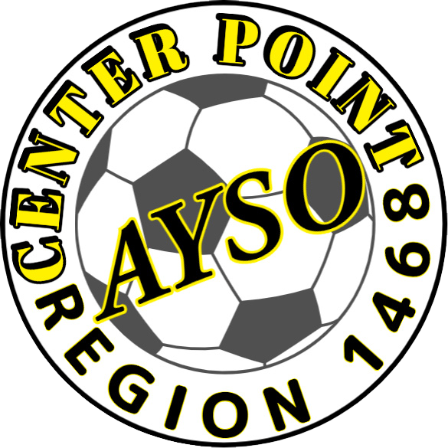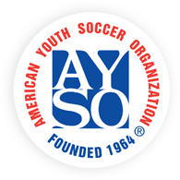 **CPU-AYSO REGION 1468**

Email Us: [registrar@cpu-ayso.org](mailto:registrar@cpu-ayso.org)

Center Point AYSO Soccer Registration

May 20-June 30

**https://www.cpu-ayso.org**

**Regional Fees – $50**

**National Fees – $25**

**$75\***

Uniforms (Separate Fee) $45.00

(2 jerseys, 2 shorts, 2 socks)

**Early Bird Special: Registrations from May 20 – May 31 $10 off!**

**Registrations after July 1 will result in an additional $10 late fee, if there is space on a team**

* Registration opens in May for the 2024(Fall) and 2025 (Spring) season.
  + U6-U8
    - Fall - Mid- August – September
    - Spring - Mid-May – June
  + U10 & Up *(CR Region sets game schedules)*
    - Fall – Mid-August – First of November
    - Spring – April – May
* One set price whether the child plays one or both seasons
* Division level is based on birth year, not grade in school

**Follow us on Facebook – CPU AYSO Soccer**

AYSO is a volunteer run organization, if interested in helping please contact us today!