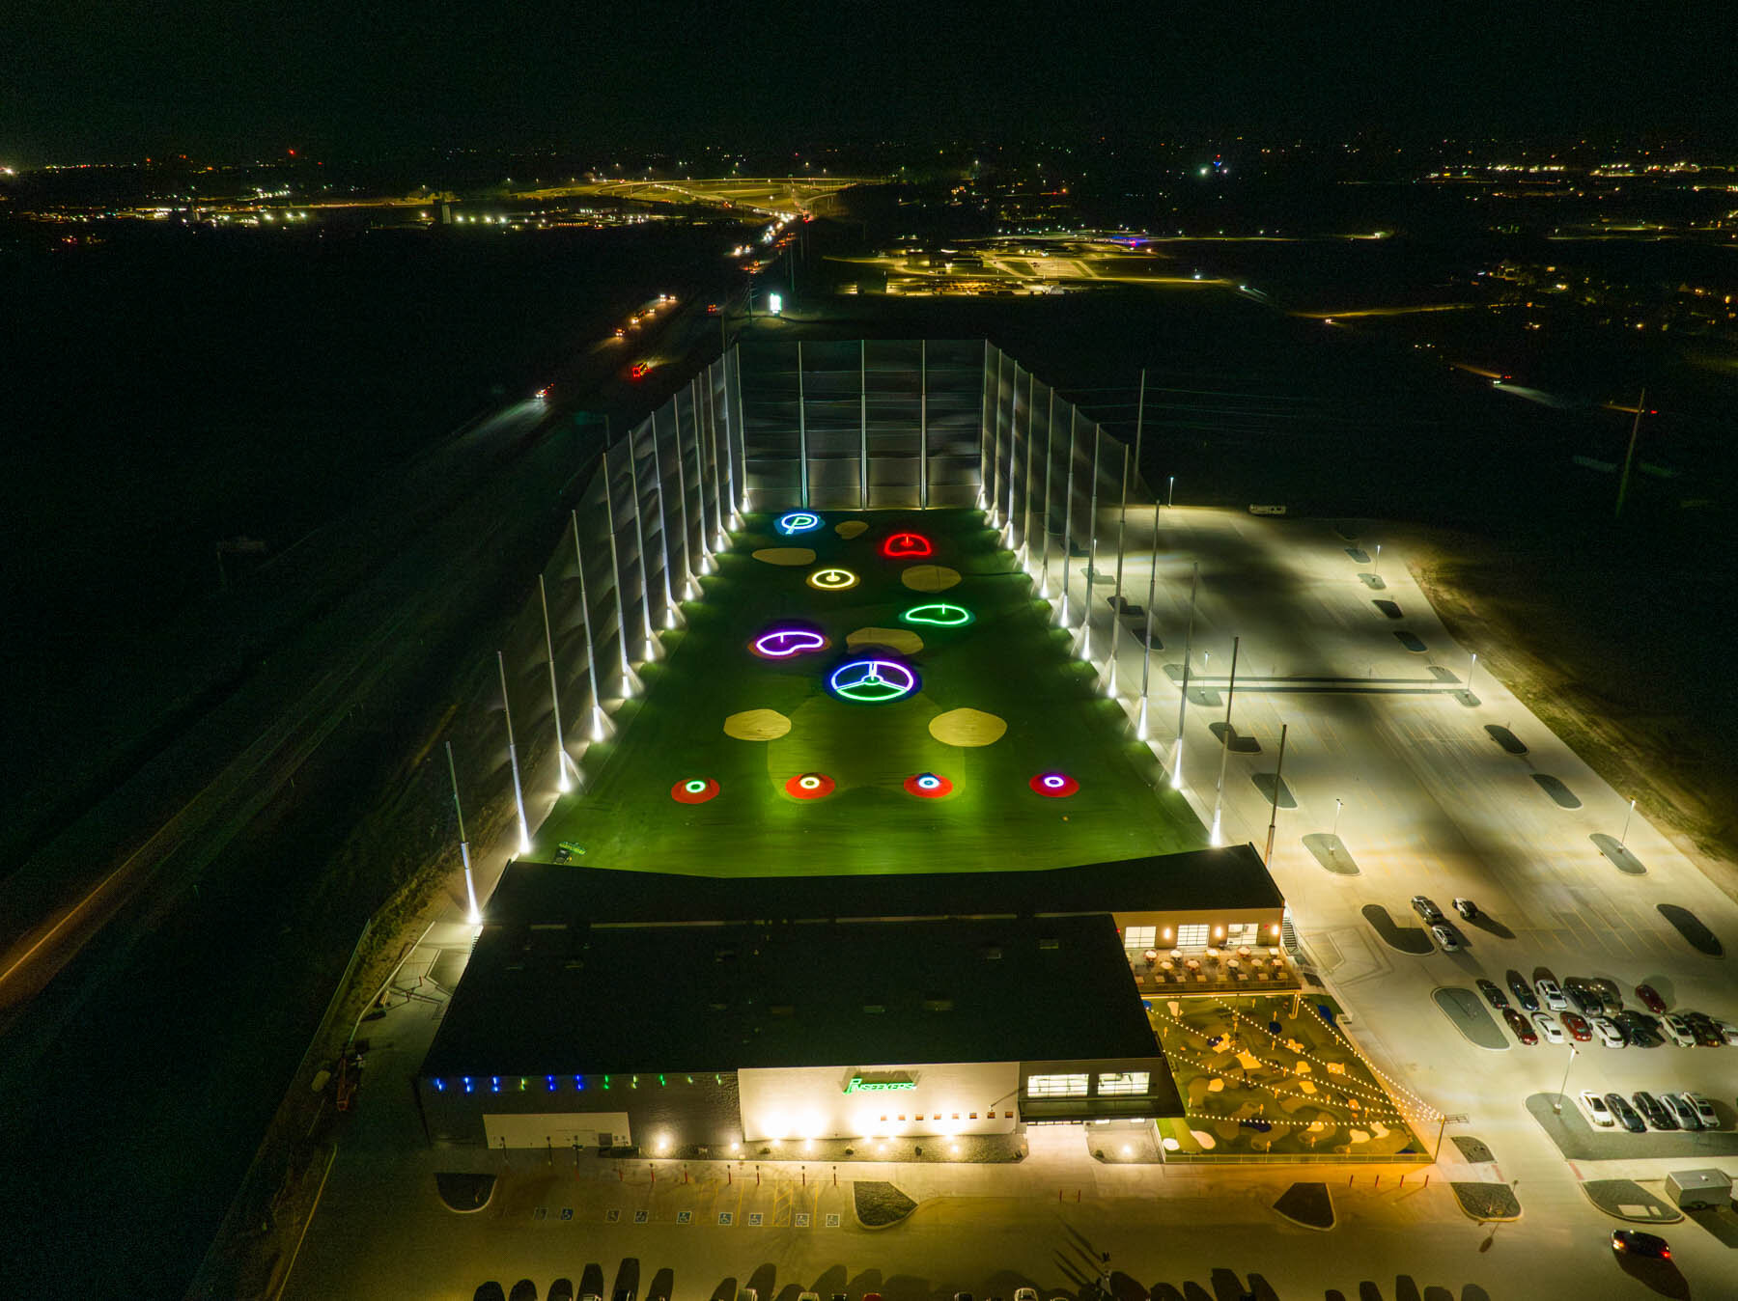
All In For Grimm
PinSeekers®
Saturday, March 7th
1:00 PM — 5:00 PM
PinSeekers
1515 Andersen Pl, Tiffin, IA 52340

TICKET PRICING
$50 FOR ADULTS
$30 CHILDREN 4–12
CHILDREN UNDER 3 FREE

WHAT YOUR TICKET INCLUDES:
• Unlimited golf, mini-golf, and mini-bowling
• $10 food voucher/adults
• $5 food voucher/children

RAFFLE
Raffles and a 50/50 drawing will be held

RSVPs are not required but helpful for bay reservations.
Please contact Jill by voice or text at 319-389-8010 for RSVPs or hotel information.
A portion of all ticket sales will go to the Grimm family.

